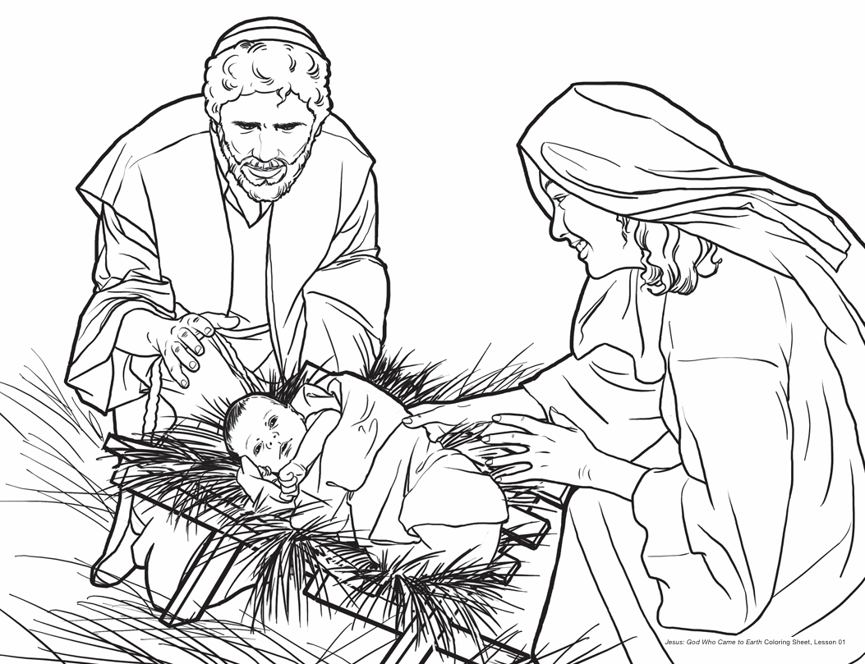
Jesus: God Who Came to Earth- Lesson 1
“For unto you is born this day in the city of David a Savior who is Christ the Lord.” Luke 2:11



Jesus: God Who Came to Earth- Lesson 2
“For unto you is born this day in the city of David a Savior who is Christ the Lord.” Luke 2:11



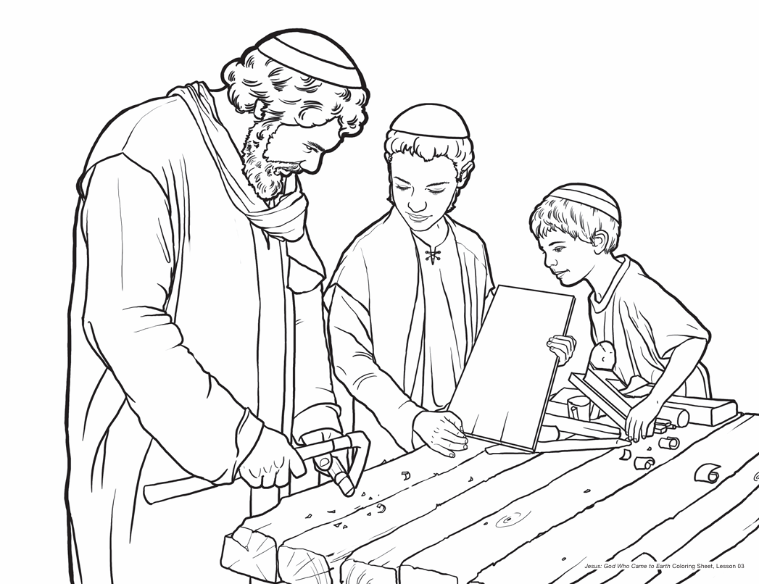
Jesus: God Who Came to Earth- Lesson 3
“For it is God who works in you, both to will and to work for his good pleasure.” Philippians 2:13
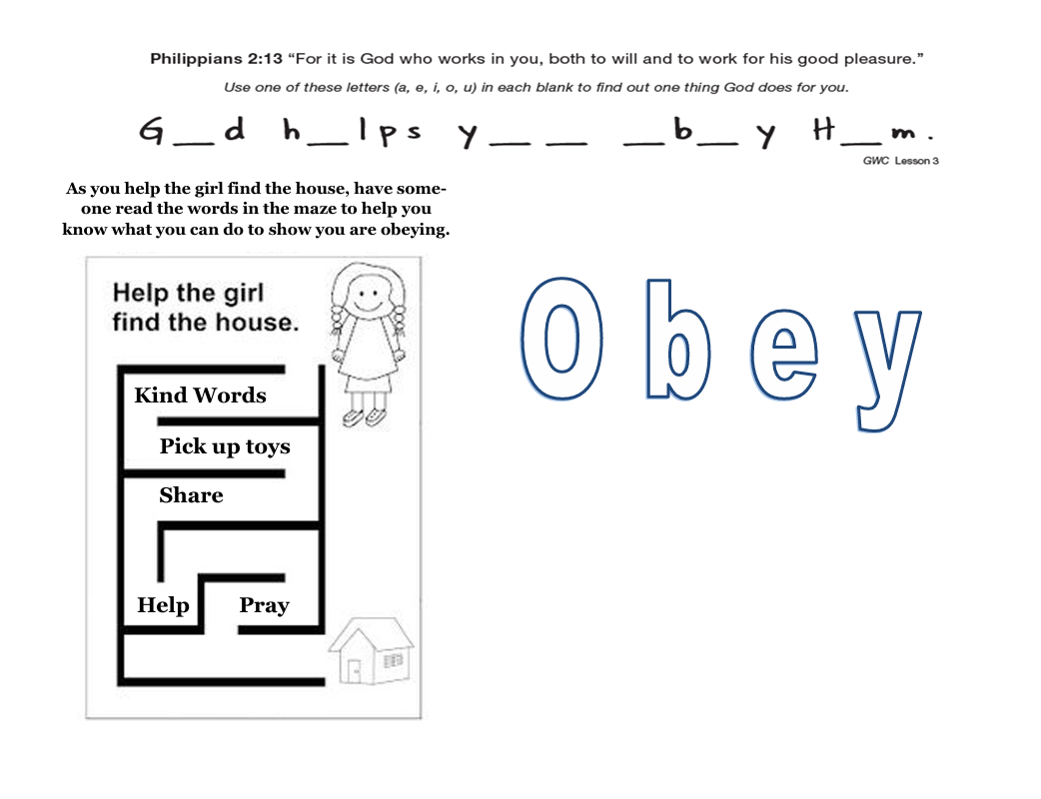


Jesus: God Who Came to Earth- Lesson 4
“For it is God who works in you, both to will and to work for his good pleasure.” Philippians 2:13



Jesus: God Who Came to Earth- Lesson 5
“For because he himself has suffered when tempted, he is able to help those who are being tempted.” Hebrews 2:18
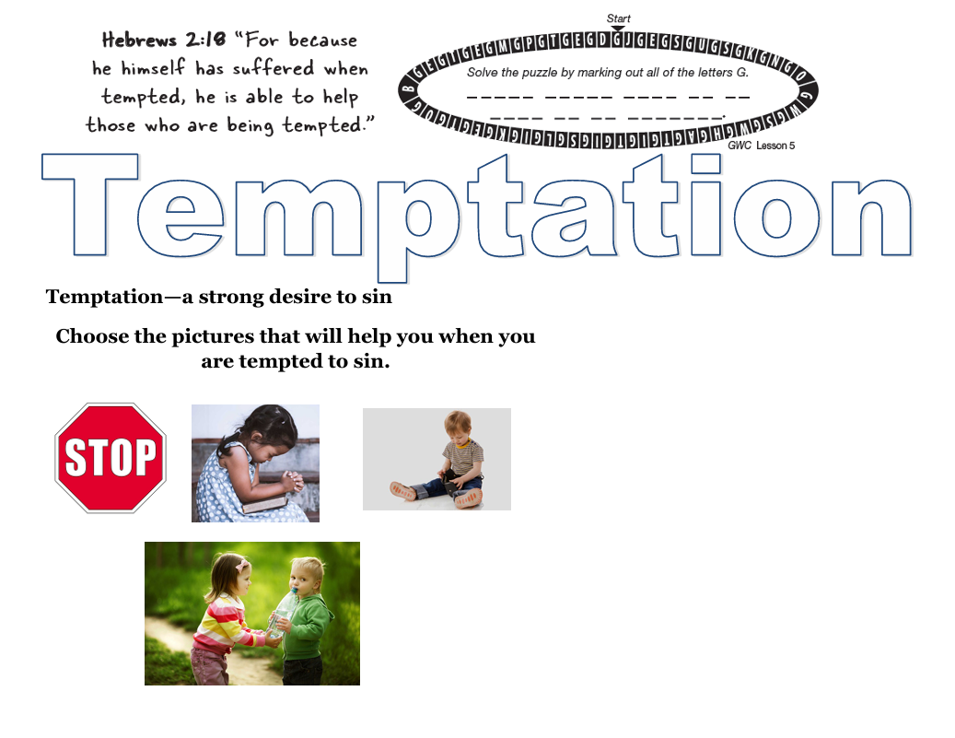


Jesus: God Who Came to Earth- Lesson 6

