5-Day Club® Ministry Information

Boys and girls are lost. Statistics show us that 80% of children do not regularly attend church.

Child Evangelism Fellowship® wants to help you take the church to the children in your neighborhood. We do this through our summer 5-Day Clubs ministry.

**5-Day Clubs** meet for 5 days (Monday-Friday) for 90 minutes each day. Children learn memory verses, hear Bible lessons, sing fun songs, and play fun interactive games!

* **5-Day Clubs are taught by young people (ages 13 and older) who have attended Christian Youth In Action® training**.
  + **5-Day Clubs** are held wherever children are - backyards, parks, trailer parks, apartment complexes, daycares, etc. Clubs can also be held in churches-VBS style.
    - **The host of the 5-Day Club** provides a club location, invites the children, and provides a small snack for the children. After the club is over, you will be given a copy of the enrollment sheets in order to keep in contact with the children and invite them to your church

**The cost:**

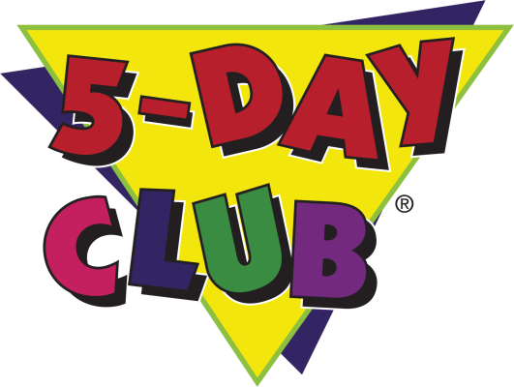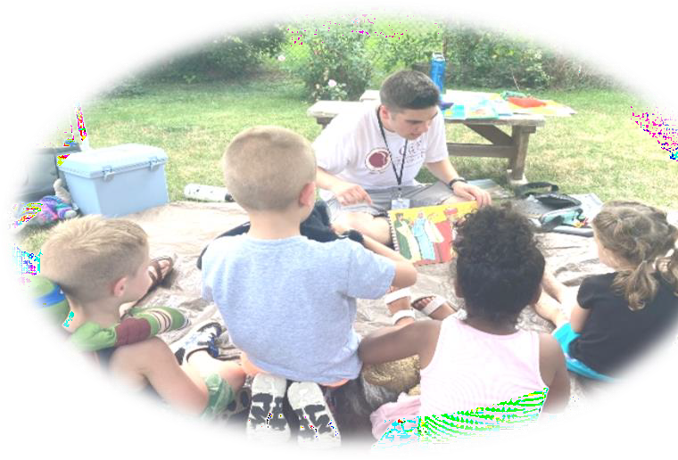

**Hosting a club is FREE! However, a donation would help to cover our costs and would be greatly appreciated! Suggested donation of $125**

All volunteers with CEF must fill out the Child Protection Policy of CEF and sign the Statement of Faith and Doctrinal Protection Policy form.

***5-Day Club* Response Form**

This form can also be filled out online at [capareacef.org/GNC and 5DC Resources](https://capareacef.org/gnc-and-5dc-resources/)

Name:

Phone:

Email:

Address:

City: State: Zip:

Best way to contact you:

Email Phone

text

Please indicate which date and time would be your first choice, then your second choice.

___June 23-27: CYIA Practice Clubs 1:30-3:00pm

___ July 14-18

___ July 21-25

Times can be adjusted in order to work best with your schedule and clubs scheduled before and after your club

___ August 4-8 __10:30am-12:00 noon

__1:00-2:30pm 3:30- 5:00pm

___ August 11-15

Club Location(s) (If different than address above):

The host/hostess of the 5-Day Club is responsible for inviting the children to the club and for providing a snack for the children (if one is given).

CEF will provide the summer missionaries, tracts, prizes and invitations for all clubs.

Interested in helping in the fair ministry?

Eaton County Fair July 7-11, 2025

Ingham County Fair July 28-August 2, 2025

You can come for a few hours one day; every day for a few hours; all day for one day...

Whatever works best with your schedule. Training on face painting and sharing the Bible Lesson are available.