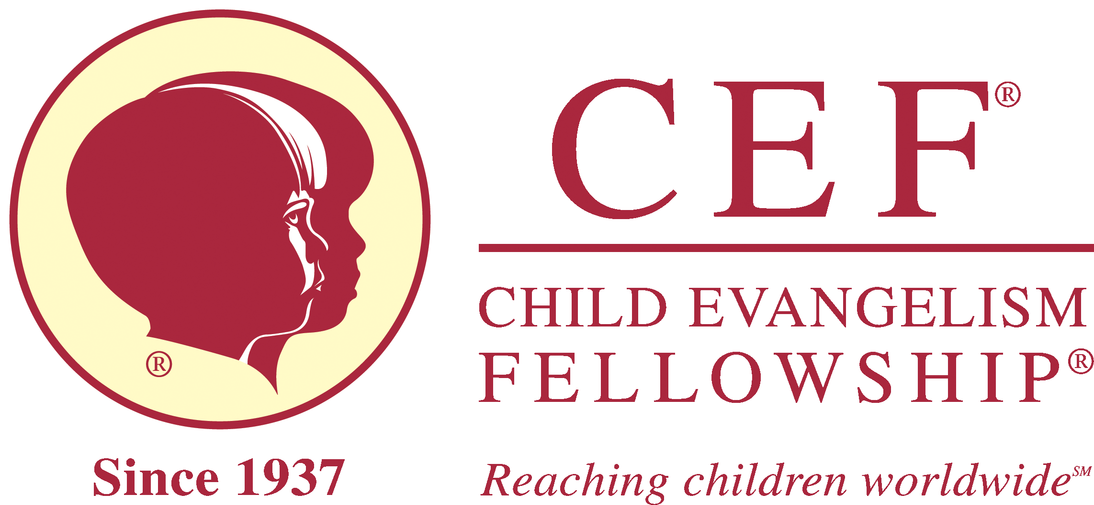
Child Evangelism Fellowship of MI
4215 W. Mt. Hope Hwy
Lansing, MI 48917
Reference Form for a Minor
517-322-0001
capareacef@gmail.com; capareacef.org

This individual has applied to Child Evangelism Fellowship® Child Protection policy to work in CEF ministry and has listed you as a reference. A personal recommendation gives insights that would be very helpful in determining the person’s ability to perform his/her responsibilities. Please print and be candid and objective.
You may also complete this form online at: Reference Form for a minor | CapAreaCef

Name of Applicant

Name of Reference

1. How long have you known the applicant? _____________________________
2. In what relationship do you know the applicant?
☐Pastor/Spiritual Leader ☐Non-relative adult friend
3. How well do you know the applicant? (circle one) ☐Very Well ☐Well ☐Casually
4. Is there any reason known to you why the applicant should not work with children? ☐ Yes ☐No
If yes, please comment
5. What is the applicant’s attitude toward authority?
☐Excellent ☐Good ☐ Average ☐Poor
6. What is the applicant’s general outlook on life?
☐Positive ☐Pos/Neg ☐ Neg/Pos ☐Negative
7. Does the applicant work well with others? ☐Yes ☐No
If no, please comment
8. Are you aware of any unbiblical sexual tendency in the applicant? ☐Yes ☐No
If yes, please comment
9. What is the applicant’s work ethic? ☐Dependable ☐Undependable
10. How would you rate the applicant’s standards for Christian living?☐Good ☐Average ☐Poor
11. How may we contact you if we have questions?
Phone: Email:

Position or occupation:

Address City St Zip

Signature: Date
(Typing your name on the signature line holds same authorization as your written signature)

Mail this reference to: CEF of MI, Capital Area Chapter
4215 W. Mt. Hope Hwy
Lansing, MI 48917

Or scan and email to: capareacef@gmail.com

