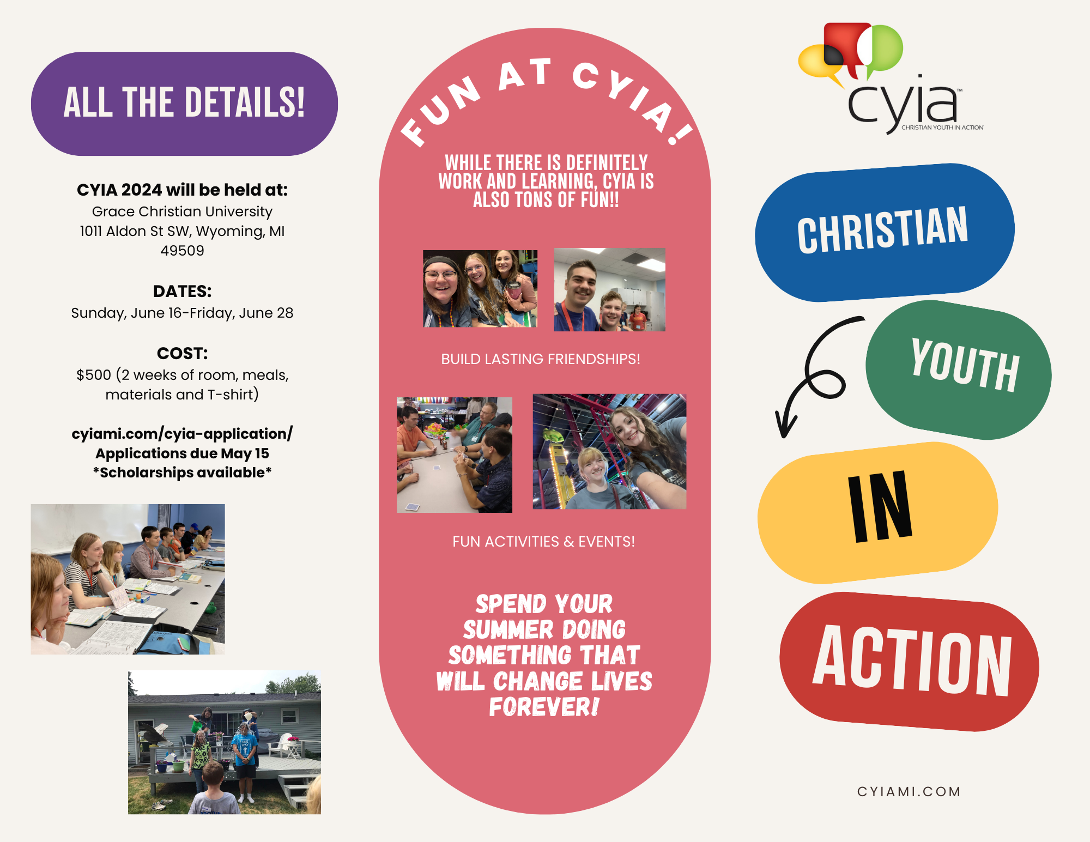

Contact: [cyiacefmi4301@gmail.com](mailto:cyiacefmi4301@gmail.com); cyiami.com; or 517-331-5525 (Maryann Hammar, CYIA Director

